## Sierran Mixed Conifer (SMC)

### General Information

### Cover Type Overview

**Sierran Mixed Conifer (SMC)**

* 297,226 acres / 120,283 hectares
* Crosswalk to EVeg: Regional Dominance Type 1
  + Mixed Conifer – Fir
  + Mixed Conifer – Pine
* Crosswalk to EVeg: Regional Dominance Type 2
  + Any
* Crosswalks for Modifiers
  + Mesic
    - BpS Model: 0610280 Mediterranean California Mesic Mixed Conifer Forest and Woodland
    - Presettlement Fire Regime Type: Moist Mixed Conifer
  + Xeric
    - BpS Model: 0610270 Mediterranean California Dry-Mesic Mixed Conifer Forest and Woodland
    - Presettlement Fire Regime Type: Dry Mixed Conifer
  + Ultramafic
    - This type is created by intersecting an ultramafic soils/geology layer with the existing vegetation layer. Where cells intersect with SMC they are assigned to the ultramafic modifier.

**Sierran Mixed Conifer with Aspen (SMC-ASP)**

* 150 acres / 61 hectares
* This type is created by overlaying the NRIS TERRA Inventory of Aspen on top of the EVeg layer. Where it intersects with SMC it is assigned to SMC-ASP

### Vegetation Description

**Sierran Mixed Conifer (SMC)** The Sierran mixed conifer (SMC) landcover type is typically composed of three or more conifers, sometimes mixed with hardwoods. In forests experiencing the natural fire regime, stand and landscape structure are both highly heterogeneous, and age structure is usually uneven. Past management (e.g. logging and fire suppression) and its effects on forest succession have resulted in greater structural homogeneity and a dramatic increase in the presence of shade tolerant/fire intolerant tree species. Old-growth stands where fire has been excluded are often multi-storied, with the overstory comprised of various species (often dominated by pines) and the understory dominated by *Abies concolor* and *Calocedrus decurrens*. In the absence of fire, forested stands can form closed, multilayered canopies with over 100% overlapping cover. Such dense stands were probably relatively uncommon before settlement, and found in moist microsites, on north slopes, and at higher elevations. When openings occur, shrubs are common in the understory. Before Euroamerican settlement, this landcover type was dominated by open stand conditions and old forest, but today closed canopy conditions dominated by middle aged trees are more common. Even aged stands are also widespread (Allen 2005).

Five conifers and one hardwood typify this landcover type: *A. concolor*, *Pseudotsuga menziesii*, *Pinus ponderosa*, *Pinus lambertiana*, *C. decurrens*, and *Quercus kelloggii*. *A. concolor* tends to be the most ubiquitous species because it is the competitive dominant in this landcover type. It tolerates shade, reproduces prolifically in the absence of fire, and has the ability to survive long periods of overtopping in brush fields. *P. menziesii* replaces white fir as the competitive dominant at lower elevations and in the northern Sierra Nevada. *P. ponderosa,* which was historically the dominant species in SMC forest, still dominates at lower elevations and on south slopes. Like *P. lambertiana*, its densities have been much reduced by logging. *Pinus jeffreyi* commonly replaces *P. ponderosa* at high elevations, on cold sites, or on ultramafic soils. *Abies magnifica* is a minor associate at the highest elevations, as are *Pinus monticola* and *Pinus contorta* ssp. *murrayana*. *P. lambertiana* is found throughout the landcover type, but its densities have been much reduced by selective logging and white pine blister rust. *Q. kelloggii* is a common component in stands on warm, dry sites. It sprouts prolifically after fire, and although it does best on open sites, it is maintained under adverse conditions such as overtopping by conifers and thin soils (Allen 2005). In some locations, *Populus tremuloides* is also a component of the stand and, when present, typically dominates during the early seral stages following disturbance.

*Ceanothus, Arctostaphylos*, *Chrysolepis*, *Prunus*, *Ribes*, *Rosa*, and *Chamaebatia* are common shrub genera in the understory (Allen 2005). Grasses and forbs are diverse but rarely contribute much cover, except where stand structure is open.

* **Mesic Modifer** The primary species associated with mesic sites are *A. concolor*, *P. menziesii, C. decurrens, and P. lambertiana*. *P. contorta* ssp. *murrayana* may also be associated with mesic forests at higher elevations. As elevations begin to increase, *A. magnifica* becomes more prominent. *Lithocarpus densiflora* is an indicator of lower elevation sites with high water availability, either from meteoric or surface water.

Understory diversity is often low in these sites, as high canopy cover and tree density reduce solar incidence at the soil surface. Very often the ground is covered in thick litter and duff. Some shade tolerant shrub and herb species occur.

* **Xeric Modifier** Xeric sites are characterized by the presence of shade intolerant/fire tolerant conifer species such as *P. ponderosa*, *P. jeffreyi*, and *P. lambertiana*, as well as the occurrence of varying amounts of more shade tolerant species like *A. concolor* and *C. decurrens* *Q. kelloggii* is locally common. The pines normally are prominent on south and west facing slopes, *A. concolor* and sometimes *P. menziesii* on north and east slopes, and *C. decurrens* as a secondary component on all slopes. At lower elevations, *Pinus sabiniana*, and *Quercus chrysolepis* may become common associates. Understory shrubs include *Ceanothus, Arctostaphylos*, *Chamaebatia,* and *Artemisia* and *Purshia* in dry, eastern sites.
* **Ultramafic Modifier** Ultramafic soils support a number of endemic plant species. Slowly growing and often stunted *P. contorta* ssp. *murrayana* and *P. jeffreyi* occur in combinations or in nearly pure open stands. Other tree associates on ultramafics include *P. menziesii*, *C. decurrens,* and *Pinus attenuata*. Hardwoods are usually sparse, but shrubs such as *Arctostaphylos*, *Quercus*, *Rhamnus*, *Lithocarpus*, *Rhododendron,* and *Ceanothus* may occur on these sites. Often, a dramatic landscape shift occurs across abrupt discontinuities between ultramafics and other rock types. For example, regional stands of dense conifer forests are replaced by stunted and open stands of other conifers, by chaparral or even by barrens on which woody vegetation is absent (“CalVeg Zone 1” 2011).

**Sierran Mixed Conifer with Aspen (SMC-ASP)** When *P. tremuloides* co-occurs with SMC on the west side of the crest, it is typically found in smaller patches, often less than 2 ha (5 acres) in size. This variant is not subject to the modifiers described above because it is only found on mesic sites. Mature stands in which *P. tremuloides* are still dominant are usually relatively open. Average canopy closures of stands in eastern California range from 60 to 100 percent in young and intermediate-aged stands and from 25 to 60 percent in mature stands. The open nature of the stands results in substantial light penetration to the ground (Verner 1988).

### Distribution

**Sierran Mixed Conifer** SMC generally forms a vegetation band ranging from 500 to 2000 m (1500 to 6500 ft). It dominates the western middle elevation slopes of the Sierra Nevada. Soils supporting SMC are varied in depth and composition, and are derived primarily from Mesozoic granitic, Paleozoic metamorphic rocks, and Cenozoic volcanic rocks (Allen 2005).

A xeric-mesic gradient was developed based on four variables: 1) aspect, 2) potential evapotranspiration, 3) topographic wetness index, and 4) soil water storage. The variables were standardized by z-score such that higher values correspond to more mesic environments. Thus, potential evapotranspiration was inverted to maintain this balance. The four variables were combined with equal weights. This final variables was split into xeric vs. mesic, with xeric occupying the negative end of the range up to ¼ standard deviation below the mean (zero) and mesic occupying the remaining portion of the spectrum.

* **Mesic Modifer** Generally found on favorable slopes, primarily north and east aspects throughout the geographic range, as well as along streams in drier areas. It is more common at higher elevations as compared to the xeric type (“CalVeg Zone 1” 2011).
* **Xeric Modifier** Occurs on south and west-facing aspects (LandFire 2007b). At lower elevations patches may be found on north slopes. At higher elevations this landcover type most typically occurs on south, east and west aspects.
* **Ultramafic Modifier**  Ultramafics have been mapped at various spatial densities throughout the elevational range of the Sierran Mixed Conifer landcover type. Low to moderate elevations in ultramafic and serpentinized areas often produce soils low in essential minerals like calcium potassium, and nitrogen, and have excessive accumulations of heavy metals such as nickel and chromium. These sites vary widely in the degree of serpentinization and effects on their overlying plant communities (“CalVeg Zone 1” 2011). Note, the terms “ultramafic rock” and “serpentine” are broad terms used to describe a number of different but related rock types, including serpentinite, peridotite, dunite, pyroxenite, talc and soapstone, among others (O’Geen et al. 2007).

**Sierran Mixed Conifer with Aspen** Sites supporting *P. tremuloides* are usually associated with added soil moisture, i.e., azonal wet sites. These sites are found throughout the SMC zone, often close to streams and lakes. Other sites include meadow edges, rock reservoirs, springs and seeps. Terrain can be simple to complex. At lower elevations, topographic conditions for this type tends toward positions resulting in relatively colder, wetter conditions within the prevailing climate, e.g., ravines, north slopes, wet depressions, etc. (LandFire 2007c).

**Disturbances**

### Wildfire

**Sierran Mixed Confier** Wildfires are common and frequent; mortality depends on vegetation vulnerability and wildfire intensity. Low mortality fires kill small trees and may consume above-ground portions of small oaks, shrubs and herbs, but do not kill large trees or below-ground organs of most oaks, shrubs and herbs which promptly resprout. High mortality fires kill trees of all sizes and may kill many of the shrubs and herbs as well. However, high mortality fires typically kill only the above-ground portions of the oaks, shrubs and herbs; consequently, most oaks, shrubs and herbs promptly re-sprout from surviving below-ground organs.

Data on fire return intervals (FRIs) are available from a few review papers. Skinner and Chang (1996) aggregated FRIs from the Sierra Nevada and separated pre-1850 data from overall data. Van de Water and Safford’s 2011 review paper aggregates hundreds of articles, conference proceedings, and LandFire data on fire return intervals, with an emphasis on Californian sources. We also include here data from the pertinent individual LandFire BpS models (2007a, 2007b, 2007c, 2007d).

* **Mesic Modifier** For moist mixed conifer forests, Van de Water and Safford (2011) found a mean fire return interval of 16 years, median of 12 years, mean min interval of 5 years and mean max of 80 years. Skinner and Chang (1996) found for Douglas-fir–mixed conifer types in the Klamath mountains a median FRI of 15 years, with a minimum of 3-12 years and a maximum of 18-59 years. Numbers for White fir–mixed conifer types were taken from studies in the Southern Cascades, Central Sierra, and Southern Sierra. Median FRI was about 12 years, with a minimum of 4 years and a maximum ranging from 24-35 years. LandFire’s Mediterranean California Mesic Mixed Conifer Forest and Woodland for the northern Sierra estimated fire intervals of 150 years for replacement fire, 45 years for mixed fire, and 35 years for surface fire, with an overall interval of 17 years (2007a). We recalculated these numbers using condition-specific information and using only high and low mortality fire categories, which resulted in a mean FRI of 106 years for high mortality fire, 20 years for low mortality fire, and 17 years for any fire. Safford (pers. comm. 2013) suggested that these values were too low; in the table below mean FRI for high mortality fire is 120 years and mean FRI for low mortality fire is 20 years.
* **Xeric Modifier** For dry mixed conifer forests, Van de Water and Safford (2011) found a mean fire return interval of 11 years, median of 9 years, mean min interval of 5 years and mean max of 50 years. Skinner and Chang (1996) found for Ponderosa pine–mixed conifer types in the Southern Sierra and Klamath Mountains a median FRI of 11, with a minimum of 4 years and a maximum ranging from 14-46 years. LandFire’s Mediterranean California Dry-Mesic Mixed Conifer Forest and Woodland for the northern Sierra estimated fire intervals of 150 years for replacement fire, 35 years for mixed fire, and 17 years for surface fire, with an overall interval of 11 years (2007b). We recalculated these numbers using condition-specific information and using only high and low mortality fire categories, which resulted in a mean FRI of 97 years for high mortality fire, 13 years for low mortality fire, and 12 years for any fire. Safford (pers. comm. 2013) suggested that the value for mean high mortality FRI was too low; in the table below mean FRI for high mortality fire is 180 years.
* **Ultramafic Modifier** Skinner and Chang (1996) reported fire intervals for *P. jeffreyi* in the Klamath Mountains. They found a median FRI of 13 years, with a minimum of 4 and a maximum of 157. This is a surprisingly short FRI, but these results are consistent with the general consensus that fire intervals on ultramafic sites are somewhat longer (due to lower productivity) and more variable than on adjacent non-ultramafic sites. Van de Water and Safford (2011) predict the same fire intervals on ultramafic sites as described above for mesic sites. The LandFire model for Klamath-Siskiyou Upper Montane Serpentine Mixed Conifer Woodland (2007d) gave an overall mean FRI of 10 years, which is likely too short. Most fires are predicted to be low mortality surface fires occurring frequently, about every 12 years ranging from 3-35 years. High mortality fires were modeled to recur between 100 and 400 years, with a mean FRI of 250 years. We recalculated these numbers using condition-specific information, and using only high and low mortality fire categories. This resulted in an interval of 50 years for high mortality fire, 11 years for low mortality fire, and 9 years for any fire. Safford (pers. comm. 2013) suggested that the value for mean high mortality FRI was too low; in the table below mean FRI for high mortality fire is 180 years. Safford (pers. comm. 2013) suggested that these values were too low; in the table below mean FRI for high mortality fire is 250 years, mean FRI for low mortality fire is 40 years, mean FRI for all fires is 30 years, and the relative proportion of high mortality to low mortality fire assigned to 5:95.

**Sierran Mixed Conifer with Aspen** Sites supporting *P. tremuloides* are maintained by stand-replacing disturbances that allow regeneration from below-ground suckers. Upland clones are impaired or suppressed by conifer ingrowth and overtopping and intensive grazing that inhibits growth. In a reference condition scenario, a few stands will advance toward conifer dominance, but in the current landscape scenario where fire has been reduced from reference conditions there are many more conifer-dominated mixed aspen stands (LandFire 2007c, Verner 1988).

Van de Water and Safford (2011) found a mean fire return interval of 19 years, median of 20 years, mean min interval of 10 years and mean max of 90 years. The LandFire model for northern Sierra Nevada aspen that is seral to conifers predicts a mean FRI of 37 years. Replacement FRI has a mean of 150 years with a range of 50-300 years, while mixed severity FRI is 250 years, and low severity fire FRI is 60 years (2007c). We reconceptualized the successional stages and converted fire activity to high and low mortality categories, which resulted in a mean FRI of 92 years for high mortality fire, 91 years for low mortality fire, and 46 years for any fire.

Table 1. Fire return intervals (years) and percentage of high versus low mortality fires in relation to soil type modifier and the presence of *P. tremuloides*. Numbers for SMC on mesic sites were derived from BpS model 0610280 (LandFire 2007a), Van de Water and Safford (2011), and Safford (pers. comm. 2013). Numbers for SMC on xeric sites were derived from BpS model 0610270 (LandFire 2007b), Van de Water and Safford (2011), and Safford (pers. comm. 2013). Numbers for SMC on ultramafic sites were derived from BpS model 0310220 (LandFire 2007d) and Safford (pers. comm. 2013). Numbers for SMC-ASP were derived from BpS model 0610610 (LandFire 2007c) and Safford (pers. comm. 2013).

|  |  |  |  |  |  |  |
| --- | --- | --- | --- | --- | --- | --- |
| **Variant** | **Modifier** | **Fire Mortality** | **Mean** | **Min** | **Max** | **% of Fires** |
| SMC | Mesic | High | 150 | – | – | 15 |
| Low | 20 | – | – | 85 |
| All Fires | 17 | 5 | 80 | 100 |
| Xeric | High | 180 | – | – | 8 |
| Low | 13 | – | – | 92 |
| All Fires | 12 | 5 | 60 | 100 |
| Ultramafic | High | 250 | – | – | 5 |
| Low | 40 | – | – | 95 |
| All Fires | 30 | 4 | 157 | 100 |
| SMC-ASP | n/a | High | 92 | – | – | 50 |
| Low | 91 | – | – | 50 |
| All Fires | 46 | 20 | 200 | 100 |

### Other Disturbance

Other disturbances are not currently modeled, but may, depending on the condition affected and mortality levels, reset patches to early development, maintain existing condition classes, or shift/accelerate succession to a more open condition. All of the tree species associated with this vegetation type are susceptible to a wide variety of pathogens and insects.

### Vegetation Condition Classes

We recognize five separate condition classes for SMC and SMC-ASP. The condition classes described below are based on the classes described in the pertinent LandFire Biophysical Setting model descriptions, which in turn were based on a “5-box” state and transition models describing major successional stages related to fire regime condition classification. According to the Fire Regime Condition Class guidebook, up to five successional classes may be utilized to describe age, size, canopy cover, and vegetation composition, ranging from early seral (post-disturbance) to late seral (such as old growth) (Barrett et al. 2010).

The SMC variant is assigned to five separate condition classes: Early Development (ED), Mid Development Open (MDO), Mid Development Closed (MDC), Late Development Open (LDO, and Late Development Closed (LDC). The SMC-ASP variant is also assigned to five condition classes: Early Development – Aspen (ED-A), Mid Development – Aspen (MD-A), Mid Development – Aspen with Conifer (MD-AC), Late Development Closed (LDC), and Late Development – Conifer with Aspen (LD-CA).

### Sierran Mixed Conifer Variant

### Early Development (ED)

##### Description This condition is characterized by the recruitment of a new cohort of early successional tree species into an open area created by a stand-replacing disturbance. After disturbance, succession proceeds from an ephemeral herb to perennial grass-herb community. This condition class generally lasts only a few years before shifting to a shrub-seedling-sapling condition dominated by any of the following genera: *Arctostaphylos*, *Ceanothus,* *Prunus*, *Ribes*, and *Chamaebatia,* as well as *Q. vaccinifolia*. Tree seedlings/saplings typical of the cover type can be either high or low density depending on local environmental conditions and climate conditions following the disturbance. In some cases (e.g., favorable climate conditions develop following the stand-replacing disturbance and a good seed source), tree seedlings may develop a nearly continuous canopy and succeed relatively quickly to mid-development conditions. In other cases, and more commonly on xeric or ultramafic sites, chaparral conditions may dominate and persist for long periods of time (LandFire 2007a, LandFire 2007b).

##### Succession Transition

* 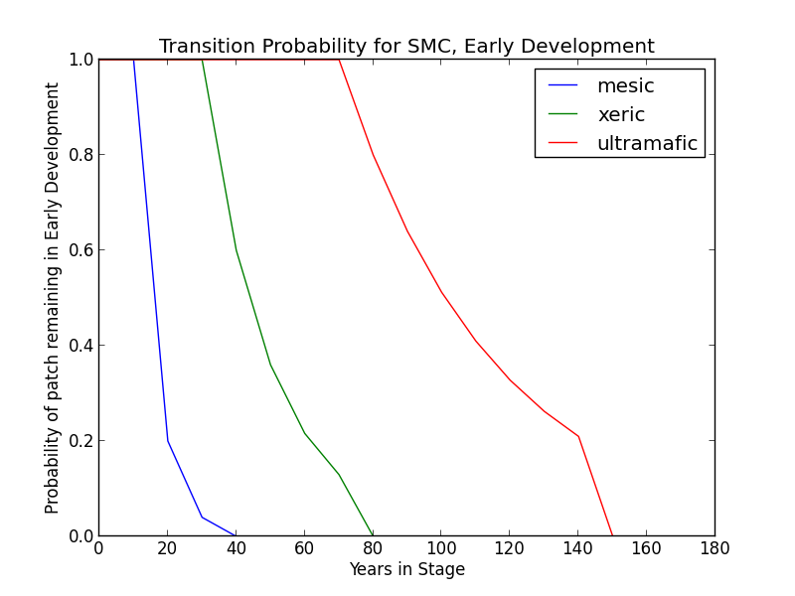**Mesic Modifier** In the absence of disturbance, this condition will begin transitioning to MDC or MDO after 20 years at a rate of 0.8 per timestep. The transition to MDC is twice as likely as transition to MDO. At 40 years, all stands will have succeeded to either MDC or MDO.
* **Xeric Modifier** Transition to the MD conditions may be substantially delayed. Thus, in the absence of disturbance, this condition will begin transitioning to MDO after 40 years and may be delayed in ED for as long as 80 years. During this period, succession occurs at a rate of 0.4 per timestep.
* **Ultramafic Modifier** Transition to the MD condition may be substantially delayed. Thus, in the absence of disturbance, this condition will begin transitioning to MDO after 80 years and may be delayed in ED for as long as 150 years. During this period, succession occurs at a rate of 0.2 per timestep.

##### Wildfire Transition High mortality wildfire (100% of fires in this condition) recycles the patch through the Early Development condition. Low mortality wildfire is not modeled for this condition.

### Mid Development - Open (MDO)

##### Description Heterogeneous ground cover of grasses, forbs, and shrubs.Trees present are pole to medium sized conifers with canopy cover less than 50% (LandFire 2007a). Conifer species likely present include *A. concolor, C. decurrens P. ponderosa, P. menziesii, and P. lambertiana*. Pines predominate on xeric sites while firs predominate on mesic sites. *Q. kelloggi* may occur as well, mostly on warmer slopes and where soils are less productive (LandFire 2007a). Ultramafic sites will have similar species composition, especially at edges, but *P. jeffreyi*, and *C. decurrens* are relatively more common (O’Geen et al. 2007).

##### Succession Transition

* 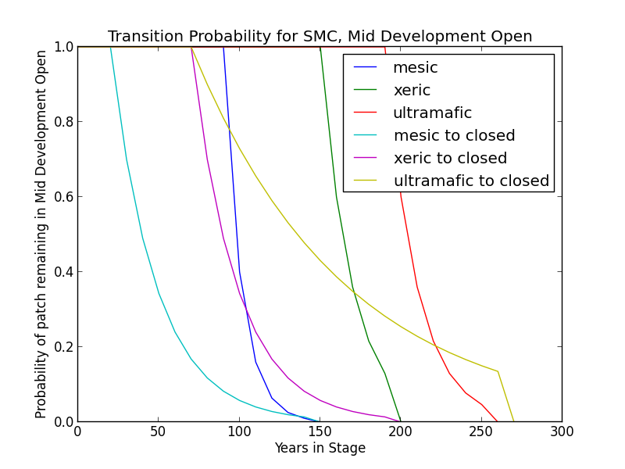**Mesic Modifier**  In the absence of low mortality disturbance, MDO will begin transitioning to MDC after 30 years at a rate of 0.9 per timestep. Succession to LDO takes place variably after 100 years since entering a middle development condition, at a rate of 0.6. All patches succeed by 150 years in MD.
* **Xeric Modifier** In the absence of low mortality disturbance, MDO will begin transitioning to MDC after 80 years at a rate of 0.3 per timetep. Succession to LDO takes place variably beginning at 160 years since transition to middle development, at a rate of 0.4 per timestep. All patches succeed by 200 years.
* **Ultramafic Modifier** In the absence of low mortality disturbance, MDO will begin transitioning to MDC after 80 years in MDO at a rate of 0.1 per timestep. Succession to LDO takes place variably beginning at 200 years since transition to middle development at a rate of 0.4 per timestep. All patches succeed by 260 years.

##### Wildfire Transition

* **Mesic Modifier** High mortality wildfire (9.5% of fires in this condition) returns the patch to Early Development. Low mortality fire (90.5%) maintains the MDO condition and allows for succession to LDO.
* **Xeric Modifier** High mortality wildfire (8.6% of fires in this condition) returns the patch to Early Development. Low mortality fire (91.4%) maintains the MDO condition and allows for succession to LDO.
* **Ultramafic Modifier** High mortality wildfire (5.6% of fires in this condition) returns the patch to Early Development. Low mortality fire (94.4%) maintains the MDO condition and allows for succession to LDO.

##### Mid Development – Closed (MDC)

##### Description Sparse ground cover of grasses, forbs, and shrubs; moderate to dense cover of trees. Conifers are pole to medium-sized, with canopy cover from 50-100%. Conifer species likely present include *A. concolor, C. decurrens, P. ponderosa, P. menziesii*, and *P. lambertiana*. *Q. kelloggi* may occur as well, mostly on warmer slopes and where soils are less productive (LandFire 2007a, LandFire 2007b). Ultramafic sites will have similar species composition, especially at edges, but *P. jeffreyi,* and *C. decurrens* are relatively more common (O’Geen et al. 2007).

##### Succession Transition

* **Mesic Modifier**  MDC persists for a minimum of 100 years in the absence of fire, at which point stands succeed to LDC at a rate of 0.6 per timestep. All patches succeed by 150 years in MD. Stands that transitioned to MDC from MDO begin transitioning to LDC once the time since transition to a mid development condition is at least 100 years.
* **Xeric Modifier** Transition to late seral conditions may be delayed. Thus, in the absence of disturbance, this condition will begin transitioning to LDC after 160 years in an MD condition at a rate of 0.4 per time step and may be delayed in the MDC condition for up to 200 years.
* **Ultramafic Modifier** Transition to late seral conditions may be substatially delayed. Thus, in the absence of disturbance, this condition will begin transitioning to LDC after 200 years in an MD condition at a rate of 0.4 per time step and may be delayed in the MDC condition for up to 260 years.

##### Wildfire Transition

* **Mesic Modifier** High mortality wildfire (11% of fires in this condition) returns the patch to ED. Low mortality wildfire (88%) opens the stand up to MDO 41.3% of the time; otherwise, the patch remains in MDC.
* **Xeric** **Modifier** High mortality wildfire (14.6% of fires in this condition) returns the patch to ED. Low mortality wildfire (85.4%) opens the stand up to MDO 51.4% of the time; otherwise, the patch remains in MDC.
* **Ultramafic Modifier** High mortality wildfire (5.3% of fires in this condition) returns the patch to ED. Low mortality wildfire (94.7%) opens the stand up to MDO 7.4% of the time; otherwise, the patch remains in MDC.

### Late Development – Open (LDO)

##### Description Heterogenous ground cover of grasses, forbs, and low shrubs; low density (less than 50% canopy cover) of large trees. Occurring in small to moderately-sized patches on southerly aspects and ridge tops. Upper canopy trees may be very large, but overall size classes vary with a patchy distribution and open canopy. This condition develops when low-mortality disturbance is fairly frequent; it persists as long as low-mortality fires continue to occur periodically. Conifer species likely present include *A. concolor, C. decurrens, P. ponderosa, P. menziesii*, and *P. lambertiana*. *Q. kelloggi* may occur as well, mostly on warmer slopes and where soils are less productive (LandFire 2007a, LandFire 2007b). Ultramafic sites will have similar species composition, especially at edges, but *P. jeffreyi,* and *C. decurrens* are relatively more common (O’Geen et al. 2007).

##### Succession Transition

* 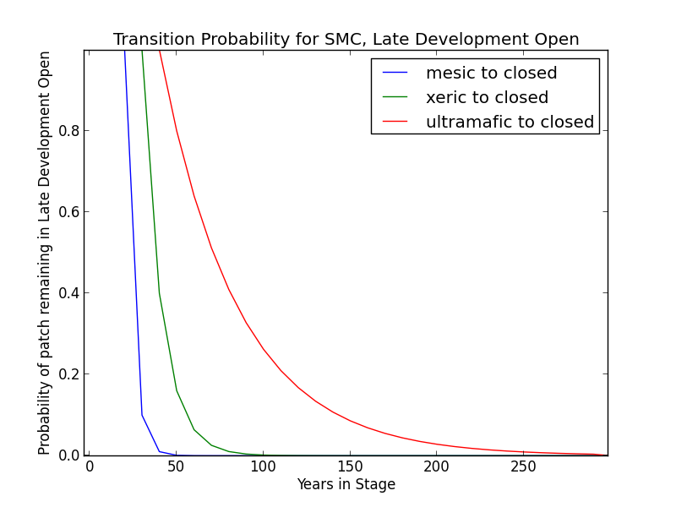**Mesic Modifier**  In the presence of low mortality disturbance, this condition can self-perpetuate, but after 30 years with no fire, patches in this condition will begin transitioning to LDC at a rate of 0.9 per timestep.
* **Xeric Modifier** Succession to LDC may occur after 40 years with no fire at a rate of 0.6 per timestep.
* **Ultramafic Modifier** Patches occurring on ultramafic soils may succeed to LDC after 50 years with no fire at a rate of 0.2 per timestep.

##### Wildfire Transition

* **Mesic Modifier** High mortality wildfire (3.6% of fires in this condition) returns the patch to early development. Low mortality wildfire (90.5%) maintains LDO.

**Xeric Modifier** High mortality wildfire (1.7% of fires in this condition) returns the patch to early development. Low mortality wildfire (98.3%) maintains LDO.

* **Ultramafic Modifier** High mortality wildfire (2.3% of fires in this condition) returns the patch to early development. Low mortality wildfire (97.7%) maintains LDO.

### Late Development – Closed (LDC)

**Description** Overstory of large and very large trees with canopy cover over 50%. Understory characterized by medium and smaller-sized shade-tolerant conifers (LandFire 2007a). Conifer species likely present include *A. concolor, C. decurrens, P. ponderosa, P. menziesii*, and *P. lambertiana*. *Q. kelloggi* may occur as well, mostly on warmer slopes and where soils are less productive (LandFire 2007a, LandFire 2007b). Ultramafic sites will have similar species composition, especially at edges, but *P. jeffreyi,* and *C. decurrens* are relatively more common (O’Geen et al. 2007).

##### Succession Transition In the absence of disturbance, this condition will maintain, regardless of soil characteristics.

##### Wildfire Transition

* **Mesic Modifier** High mortality wildfire (31.2% of fires in this condition) will return the patch to Early Development. Low mortality wildfire (68.8%) usually has little effect, although 29.9% of the time it opens the stand up to LDO.
* **Xeric Modifier** High mortality wildfire (34% of fires in this condition) will return the patch to Early Development. Low mortality wildfire (66%) usually has little effect, although 7.6% of the time it opens the stand up to LDO.
* **Ultramafic Modifier** High mortality wildfire (10% of fires in this condition) will return the patch to Early Development. Low mortality wildfire (90%) usually has little effect, although 7.4% of the time it opens the stand up to LDO.

### Aspen Variant

### Early Development – Aspen (ED–A)

**Description** Grasses, forbs, low shrubs, and sparse to moderate cover of tree seedlings/saplings (primarily *P. tremuloides*) with an open canopy. This condition is characterized by the recruitment of a new cohort of early successional, shade-intolerant tree species into an open area created by a stand-replacing disturbance.

Following disturbance, succession proceeds rapidly from an herbaceous layer to shrubs and trees, which invade together (Verner 1988). *P. tremuloides* suckers over 6ft tall develop within about 10 years (LandFire 2007c).

**Succession Transition** Unless it burns, a patch in the Early Development – Aspen condition persists for 10 years, at which point it transitions to MD-A.

**Wildfire Transition** High mortality wildfire (100% of fires in this condition) recycles the patch through the ED–A condition. Low mortality wildfire is not modeled for this condition.

### Mid Development – Aspen (MD–A)

##### Description *P. tremuloides* trees 5-16in DBH. Canopy cover is highly variable, and can range from 40-100%. These patches range in age from 10 to 110 years. Some understory conifers, including *P. ponderosa*, *P. lambertiana*, and *A. concolor* are encroaching, but *P. tremuloides* is still the dominant component of the stand (LandFire 2007c).

##### Succession Transition MD-A persists for at least 50 years in the absence of fire, after which stands begin transitioning to MD-AC at a rate of 0.6 per timestep. After 100 years since entering MD-A, any remaining patches transition to MD-AC.

##### Wildfire Transition High mortality wildfire (100% of fires in this condition) recycles the patch through the ED–A condition. Low mortality wildfire is not modeled for this condition.

**Mid Development – Aspen with Conifer (MD–AC)**

**Description** These stands have been protected from fire since the last stand-replacing disturbance.. *P. tremuloides* trees are predominantly 16in DBH and greater. Conifers are present and overtopping the *P. tremuloides*. *A. concolor* is a typical conifer that is successional to *P. tremuloides*, and is depicted here, but other conifers including *P. ponderosa* and *P. lambertiana* are also possible. Conifers are pole to medium-sized, and conifer cover is at least 40% (LandFire 2007c).

**Succession Transition** MD-AC persists for 100 years in the absence of fire, after which stands transition to LDC.

**Wildfire Transition** High mortality wildfire (70% of fires in this condition) returns the patch to ED-A. Low mortality wildfire (30%) maintains the patch in MD–AC.

### Late Development – Closed (LDC)

**Description** Some *P. tremuloides* continue to be present in the understory, but large conifers are now the dominant tree species, having overtopped the *P. tremuloides.* Smaller conifers are present in the midstory as well. Conifer species likely present include *A. concolor, C. decurrens, P. ponderosa, P. menziesii*, and *P. lambertiana*. (LandFire 2007a, LandFire 2007b, LandFire 2007c). This condition class is analogous to the LDC condition for the SMC variant.

##### Succession Transition In the absence of disturbance, this condition will maintain, regardless of soil characteristics.

##### Wildfire Transition High mortality wildfire (9% of fires in this condition) will return the patch to ED–A. Low mortality wildfire (91%) usually has little effect, although 15% of the time it opens the stand up to LD-CA.

**Late Development – Conifer with Aspen (LD–CA)**

**Description** If stands are sufficiently protected from fire such that conifer species overtop *P. tremuloides* and become large, they may be able to withstand some fire that more sensitive *P. tremuloides* cannot. When this occurs, it creates a patch characterized by late development conifers, such as *A. concolor, P. ponderosa,* or *P. lambertiana*, and early seral *P. tremuloides*.

**Succession Transition** LD-CA persists for 70 years in the absence of fire, after which stands transition to LDC.

**Wildfire Transition** High mortality wildfire (20% of fires in this condition) returns the patch to ED-A. Low mortality wildfire (80%) maintains the stand in LD-CA.

**Condition Classification**

Table 2. Classification of cover condition for SMC. Diameter at Breast Height (DBH) and Cover From Above (CFA) values taken from EVeg polygons. DBH categories are: null, 0-0.9”, 1-4.9”, 5-9.9”, 10-19.9”, 20-29.9”, 30”+. CFA categories are null, 0-10%, 10-20%, … , 90-100%. Each row in the table below should be read with a boolean AND across each column.

|  |  |  |  |  |  |
| --- | --- | --- | --- | --- | --- |
| Cover Condition | Overstory Tree  Diameter 1 (DBH) | Overstory Tree  Diameter 2 (DBH) | Total Tree  CFA (%) | Conifer  CFA (%) | Hardwood  CFA (%) |
| Early All | null | any | any | any | any |
| Early All | 0-4.9” | any | any | any | any |
| Mid Open | 5-19.9” | any | null | null | null |
| Mid Open | 5-19.9” | any | <50 | any | any |
| Mid Open | 5-19.9” | any | null | <50 | null |
| Mid Closed | 5-19.9” | any | >50 | any | any |
| Mid Closed | 5-19.9” | any | null | >50 | any |
| Late Closed | 20”+ | any | >50 | any | any |
| Late Closed | 20”+ | any | null | >50 | any |
| Late Open | 20”+ | any | null | null | null |
| Late Open | 20”+ | any | <50 | any | any |
| Late Open | 20”+ | any | null | <50 | null |

Methodology for assigning condition classes to SMC-ASP is still under development.

**Draft Model**

(See PDF) Disturbance-Succession model for SMC and SMC-ASP.

**References**

Allen, Barbara H. “Sierran Mixed Conifer (SMC).” *A Guide to Wildlife Habitats of California*, edited by Kenneth E. Mayer and William F. Laudenslayer. California Deparment of Fish and Game, 1988, updated 2005. <http://www.dfg.ca.gov/biogeodata/cwhr/pdfs/SMC.pdf>. Accessed 4 December 2012.

Barrett, S., D. Havlina, J. Jones, W. Hann, C. Frame, D. Hamilton, K. Schon, T. Demeo, L. Hutter, and J. Menakis. *Interagency Fire Regime Condition Class Guidebook*. Version 3.0. USDA Forest Service, US Department of the Interior, and The Nature Conservancy, 2010. <http://www.frcc.gov>. Accessed 5 June 2013.

“CalVeg Zone 1.” Vegetation Descriptions. *Vegetation Classification and Mapping*. 11 December 2008. U.S. Forest Service. <http://www.fs.usda.gov/Internet/FSE_DOCUMENTS/fsbdev3_046448.pdf>. Accessed 2 April 2013.

LandFire. “Biophysical Setting Models.” Biophysical Setting 0610280. 2007a. LANDFIRE Project, U.S. Department of Agriculture, Forest Service; U.S. Department of the Interior. <http://www.landfire.gov/national_veg_models_op2.php>. Accessed 9 November 2012.

LandFire. “Biophysical Setting Models.” Biophysical Setting 0610270. 2007b. LANDFIRE Project, U.S. Department of Agriculture, Forest Service; U.S. Department of the Interior. <http://www.landfire.gov/national_veg_models_op2.php>. Accessed 9 November 2012.

LandFire. “Biophysical Setting Models.” Biophysical Setting 0610610. 2007c. LANDFIRE Project, U.S. Department of Agriculture, Forest Service; U.S. Department of the Interior. <http://www.landfire.gov/national_veg_models_op2.php>. Accessed 7 January 2013.

LandFire. “Biophysical Setting Models.” Biophysical Setting 0711700. 2007d. LANDFIRE Project, U.S. Department of Agriculture, Forest Service; U.S. Department of the Interior. <http://www.landfire.gov/national_veg_models_op2.php>. Accessed 30 November 2012.

O’Geen, Anthony T., Randy A. Dahlgren, and Daniel Sanchez-Mata. “California Soils and Examples of Ultramafic Vegetation.” In *Terrestrial Vegetation of California, 3rd Edition*, edited by Michael Barbour, Todd Keeler-Wolf, and Allan A. Schoenherr, 71-106. Berkeley and Los Angeles: University of California Press, 2007.

Safford, Hugh S. Personal communication, 5 May 2013.

Skinner, Carl N. and Chi-Ru Chang. “Fire Regimes, Past and Present.” *Sierra Nevada Ecosystem Project: Final report to Congress, vol. II, Assessments and scientific basis for management options*. Davis: University of California, Centers for Water and Wildland Resources, 1996.

Van de Water, Kip M. and Hugh D. Safford. “A Summary of Fire Frequency Estimates for California Vegetation Before Euro-American Settlement.” *Fire Ecology* 7.3 (2011): 26-57. doi: 10.4996/fireecology.0703026.

Verner, Jared. “Aspen (ASP).” ).” *A Guide to Wildlife Habitats of California*, edited by Kenneth E. Mayer and William F. Laudenslayer. California Deparment of Fish and Game, 1988. <http://www.dfg.ca.gov/biogeodata/cwhr/pdfs/ASP.pdf>. Accessed 4 December 2012.